**N4DAC02 2-channel RS485 DAC module**

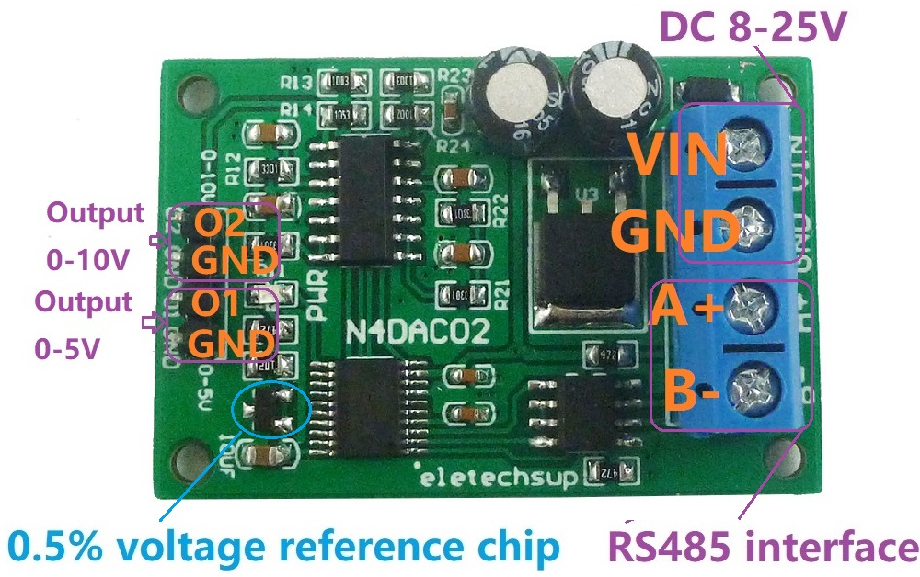**Features:**

1: Operating Voltage : DC 12 (DC 12-25V), recommended power supply with small ripple

2: Operating Current : 12-13MA

3: MODBUS RTU Command support 03 06 function code

4: CH1(O1) output voltage is 0-5V, maximum output current is 20MA. 1-5V accuracy 1%, <1V there is a ripple of 50HZ/40MV.

CH2(O2) output voltage is 0-10V, maximum output current is 20MA. 2-10V accuracy 1%, <2V there is a ripple of 50HZ/80MV.

5: The voltage resolution is 0.01V, the output accuracy is 1%; if the error is greater than 1%, it can be calibrated

6 :MODBUS commands can be made serial HyperTerminal (serial assistant) OR PLC Enter;

7 :Under the MODBUS command mode, it can support up to 247 devices in parallel

8 :Size: 45 * 35 * 15mm

9 :Weight: 10g

Slave ID: Different "Sliver ID" can be set by command, the maximum number is 247

Under the MODBUS command mode,the slave ID must be correct

Modbus RTU Command Please refer to : "N4DAC02 modbus rtu protocol "

Note:

This is a low-cost digital-to-analog conversion module based on the PWM+ADC solution. It has the following disadvantages:

1 channel 1 (O1) has 1% accuracy at 1-5V, <1V has 50HZ/40MV ripple, channel 2 (O2) has 1% accuracy at 2-10V, and <2V has 50HZ/80MV Ripple.

2 channel 1 (O1) minimum output voltage is 0.05V, channel 2 (O2) minimum output voltage is 0.1V

3 There is a 10-20MS high pulse at the moment of power-on

**Wiring diagram:**

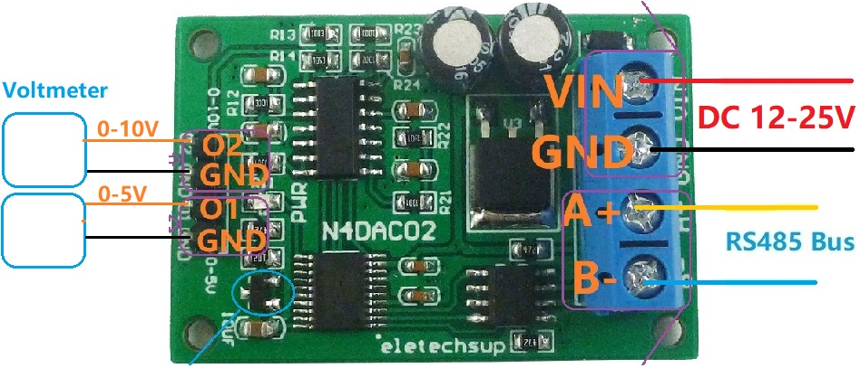

Command Description, Please refer to " N4AIA04 modbus rtu protocol "

